<https://www.cambly.com/en/student/courses/5eb03d0f9934e038cfcf0372/5eb04c88637276b84a96d2bf>



## notes

|  |  |  |
| --- | --- | --- |
| Producers  manufactures | /ˌmænjʊˈfæktʃəz/ | the organized action of making of goods and services for sale |
| Warehouse  hub | /ˈweəhaʊs/ | a storehouse for goods and merchandis; warehouse management data warehouse |
| Comments  Good ratings  Good reviews | /ˈkɒments/ |  |
| Robots in factories instead of workers |  |  |
|  |  |  |

|  |  |  |
| --- | --- | --- |
| Domain  Home page | /doʊˈmeɪn/ | The root address for a website or web page |
| 1. Commerce   E-business | /i:kɒmərs/ | Buying and selling of goods or services using the Internet  commerce conducted electronically (as on the internet) |
| Search **engine** | /ˈendʒɪn/ | A computer program that finds information on the internet by looking for words that you have typed in (e.g. Google, Yahoo, Bing, etc.) |
| Conversion rate | /kənˈvɜːʃn/ | The number of sales of a product compared to the number of people who visit a website to look at that product  For example  100 looking at the pair of trainers like looking at the product and 3 people buy it. It’s three divided by 100 so it’s like your conversion rate.  in internet marketing, the conversion rate is the proportion of visits to a website who take action to go beyond a casual content view or website visit, as a result of subtle or direct requests from marketers, advertisers, and content creators. |
| transaction | /trænˈzækʃ(ə)n/ | The activity of buying or selling something;  the act of transacting within or between groups (as carrying on commercial activities) |
| To fulfill  Meet  Satisfy  Fill  accomplish  Fulfill oneself | /fʊlˈfɪl/ | To finish a task or accomplish what has been asked;  To supply what has been ordered  Send ----Delivery --Receive  履行；实现；满足；使结束 |
| Easy-to-remember |  |  |
| Marketing strategies | /ˈstrætədʒiz/ | Marketing stra-te-gies |
| Amount  account | əˈkaʊnt/ | 数量，量；金额，钱数；  a formal contractual relationship established to provide for regular banking or brokerage or business services |

The differences between online (e-commerce) and physical stores (brick-and-mortar):

1. Deliver time (immediately, wait)
2. More choices online, compare the similar product among different stores
3. Check comments online

## Lesson

### Lesson 20221013

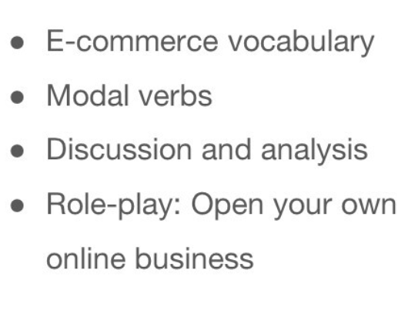

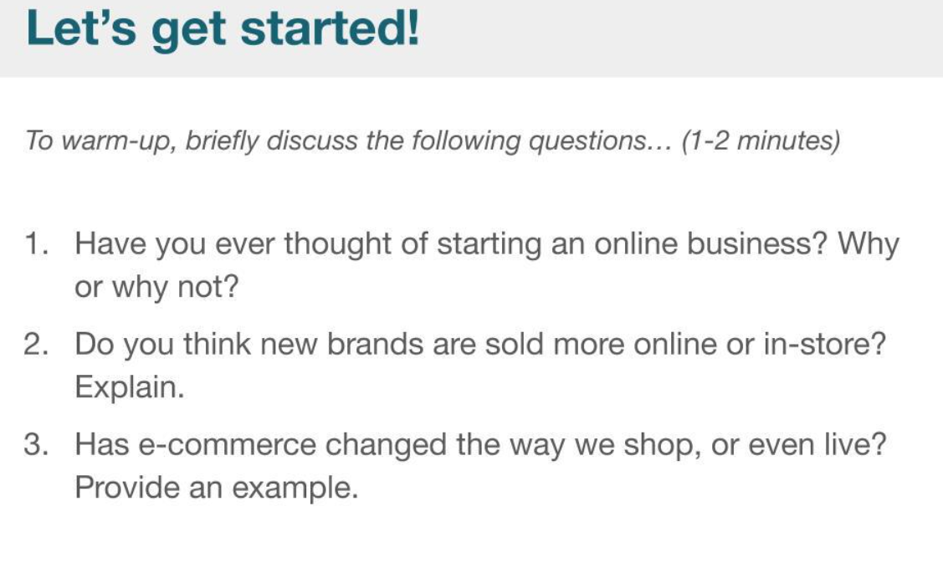

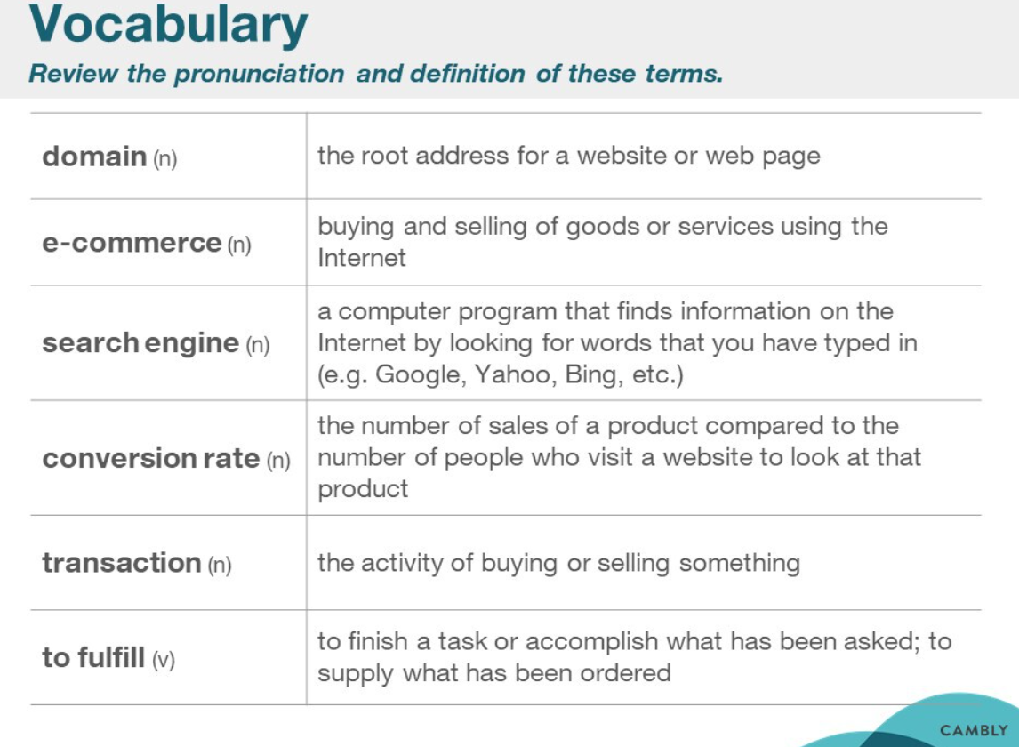

|  |  |  |
| --- | --- | --- |
| Domain  Home page | /doʊˈmeɪn/ | The root address for a website or web page |
| 1. Commerce   E-business | /i:kɒmərs/ | Buying and selling of goods or services using the Internet  commerce conducted electronically (as on the internet) |
| Search **engine** | /ˈendʒɪn/ | A computer program that finds information on the internet by looking for words that you have typed in (e.g. Google, Yahoo, Bing, etc.) |
| Conversion rate | /kənˈvɜːʃn/ | The number of sales of a product compared to the number of people who visit a website to look at that product  For example  100 looking at the pair of trainers like looking at the product and 3 people buy it. It’s three divided by 100 so it’s like your conversion rate.  in internet marketing, the conversion rate is the proportion of visits to a website who take action to go beyond a casual content view or website visit, as a result of subtle or direct requests from marketers, advertisers, and content creators. |
| transaction | /trænˈzækʃ(ə)n/ | The activity of buying or selling something;  the act of transacting within or between groups (as carrying on commercial activities) |
| To fulfill  Meet  Satisfy  Fill  accomplish  Fulfill oneself | /fʊlˈfɪl/ | To finish a task or accomplish what has been asked;  To supply what has been ordered  Send ----Delivery --Receive  履行；实现；满足；使结束 |

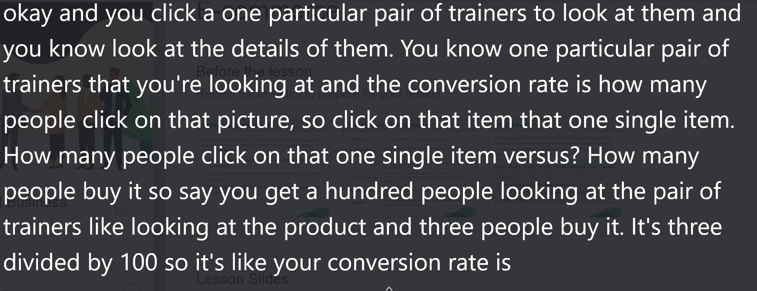

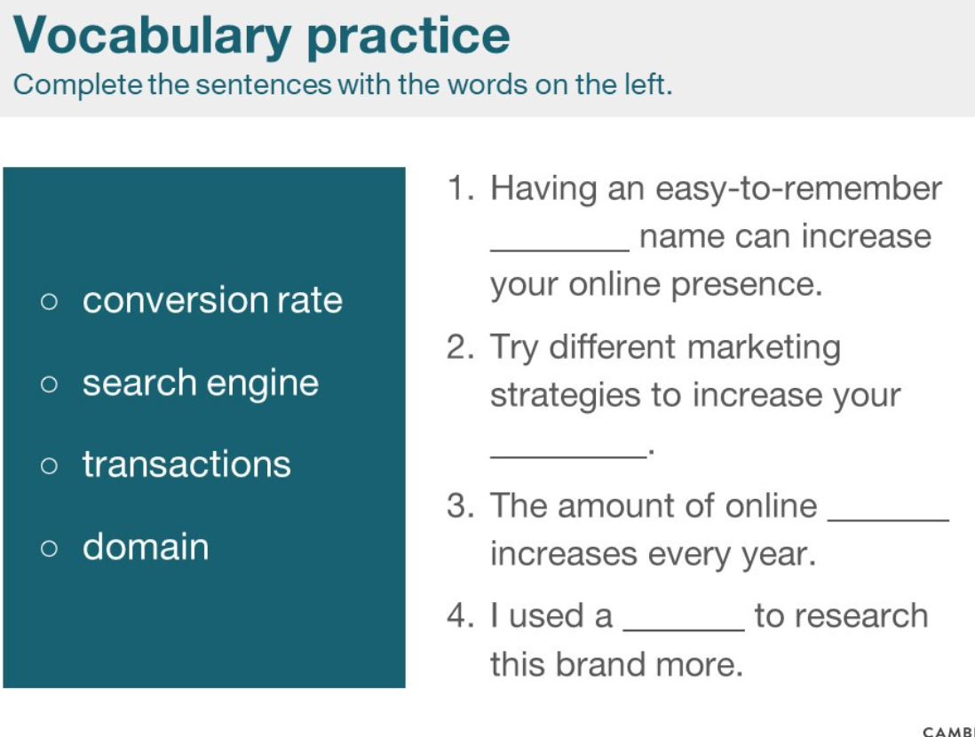

|  |  |  |
| --- | --- | --- |
| Easy-to-remember |  |  |
| Marketing strategies | /ˈstrætədʒiz/ | Marketing stra-te-gies |
| Amount  account | əˈkaʊnt/ | 数量，量；金额，钱数；  a formal contractual relationship established to provide for regular banking or brokerage or business services |

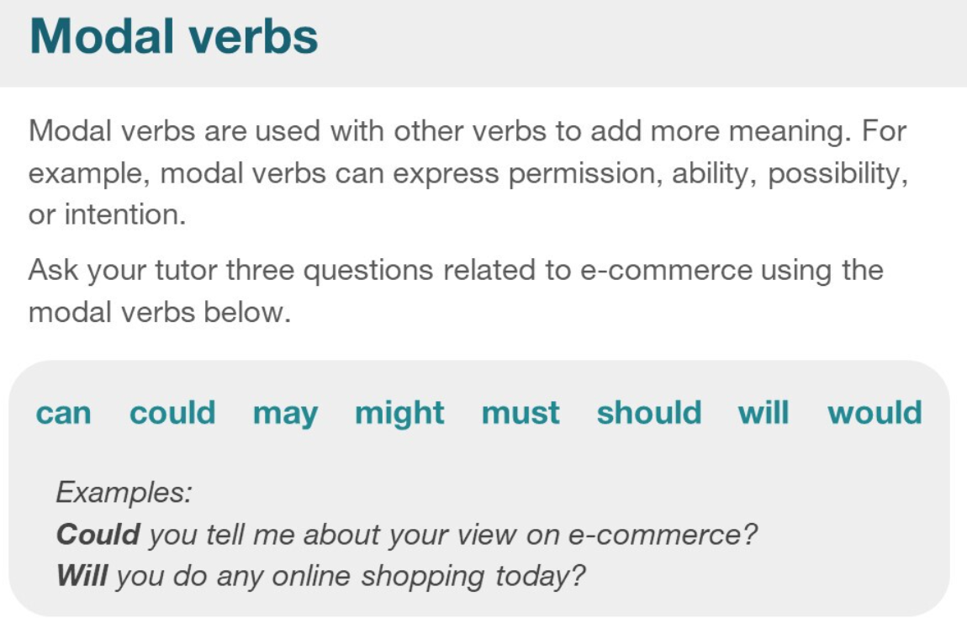

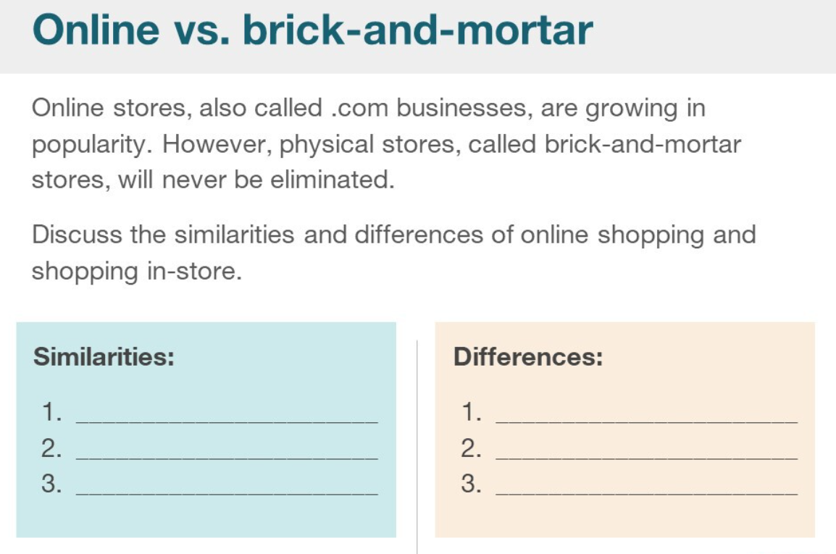

The differences between online (e-commerce) and physical stores (brick-and-mortar):

1. Deliver time (immediately, wait)
2. More choices online, compare the similar product among different stores
3. Check comments online

### Lesson 20221014

